**AIM**: Description about **CodeHacker** Project.

* CodeHacker have 6 Application which are following:

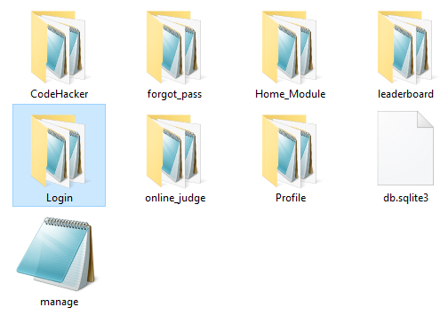

**CodeHacker:**

* CodeHacker is our Project Name. It contains two files which are following.

**1.urls.py:**

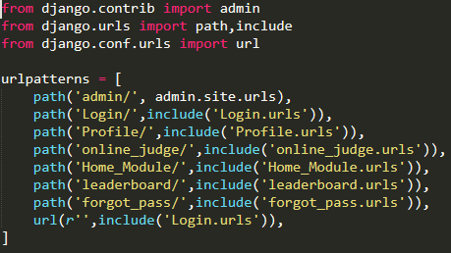

* urls.py contains all application url of project.

**2.setting.py**

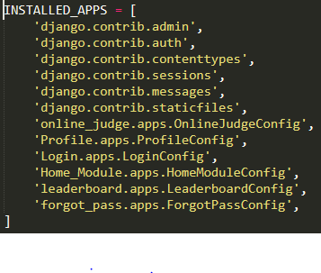

* in setting.py we need to mention all application’s config name.

**Applications:**

**1)Login:**

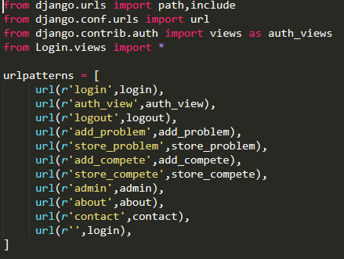

* Login application use for login and it gives a functionality for admin to add problems and challenges.

**2)Profile:**

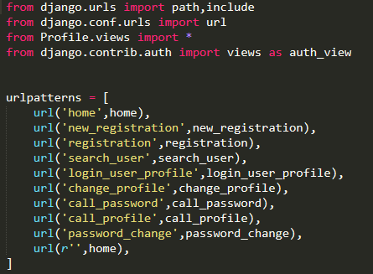

* Profile application use for registration, show a user profile and gives a functionality for user to change profile details and password.

**3)Home_Module:**

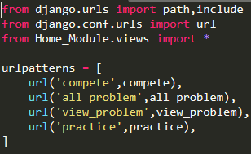

* Home_Module application contains all main pages like header, compete, home, problem etc.

**4)leaderboard:**

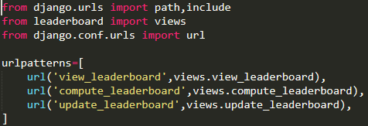

* leaderboard application show the leaderboard of challenges.

**5)forgot_pass:**

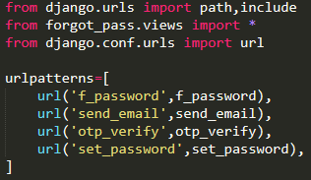

* forgot_pass application useful for users who forgot their password.

**6)online_judge:**

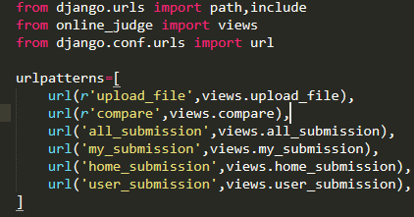

* online_judge application use for judging the problem and tell users that their answer is right or wrong and also show the submission of the all users.